Physical Geology Date _________ Name ________________________
Dr. Jan Rasmussen jrasmussen@pima.edu http://www.janrasmussen.com

Mass Movement (Landslides, etc.) – Chapter 9 Lab Exercise

Using the aerial photos and explanatory material supplied by your instructor and the diagrams and information in Chapter 9 of your textbook, answer the following questions associated with the aerial photographs and topographic maps.

1. Rio Grande Canyon, plate 6 of Aerial Stereo Photographs
1. Mark in red on the handout photo where the scarps of the landslides are.
2. Mark in blue on the handout photo where the hummocky (rumpled/lumpy) surface near the toes of the slides are.
3. Mark in green on the handout the slumped blocks showing the flat surface at a lower elevation than the main plateau.
a. Is the lower flat area tilted back toward the cliff where it came from or is it tilted down toward the canyon?

b. Draw a diagram of how this would look in a cross section.

- What hazards exist for the highway through the canyon?

2. Gros Ventre slide, Wyoming, plate 8 of Aerial Stereo Photographs

1. Label and mark in red on the handout photo where the scarps of the landslides are.

2. Label and mark in blue on the handout photo where the hummocky (rumpled or lumpy) surface near the toes of the slides are.

3. Outline in green the area of the slide.

4. Describe the features of the area that predisposed it to slide.

- Mark the cracks at B.5 – 3.2 (in the center of the left photo).

- How did the lake form?

- What could happen in the future?
6 Rio Grande Canyon 8 Gros Ventre slide
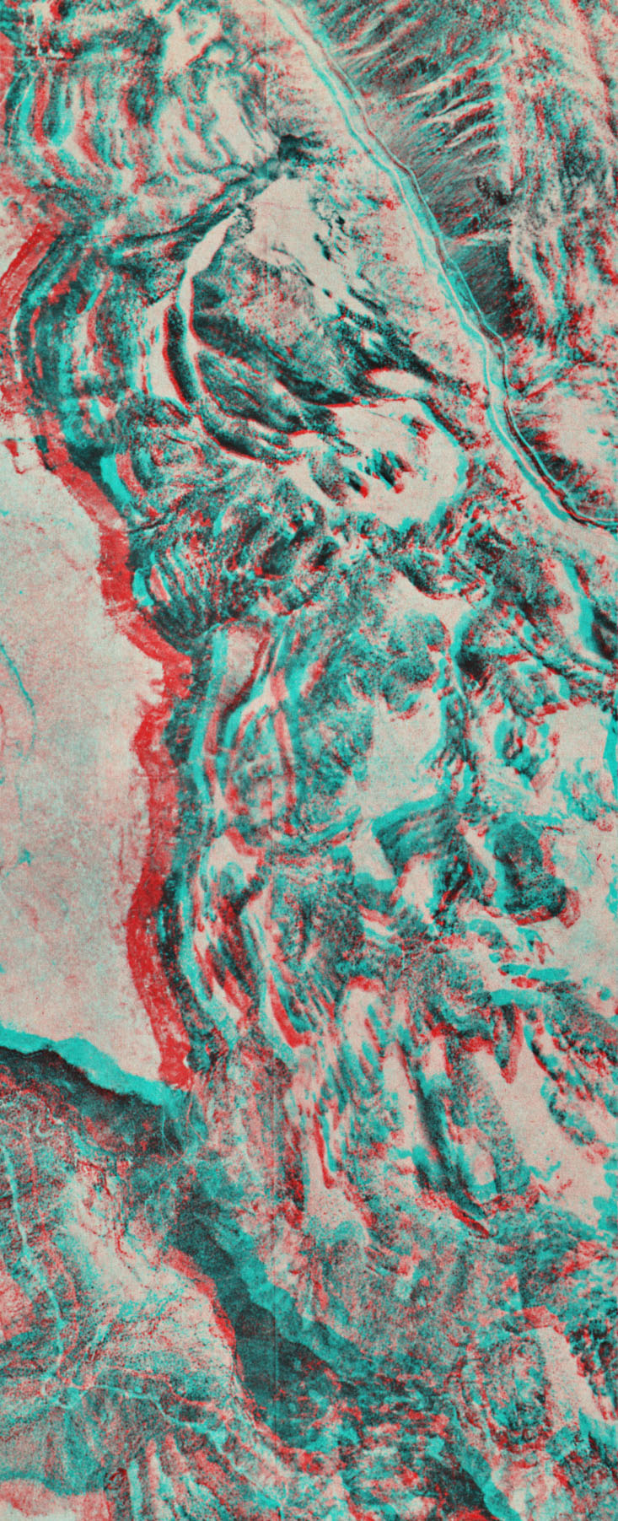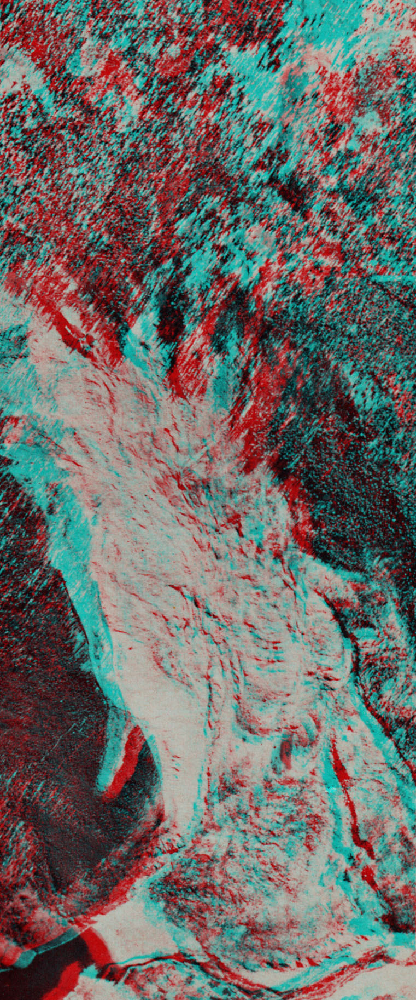

Use the red/blue 3-D glasses to look at these photos.

- San Juan Mountains, Colorado (Hamblin & Howard lab manual p. 124)

1a. List the types of mass movement that you can identify on this set of aerial photographs.

1b. One type of mass movement in this area forms large, tongue-like landforms with a wrinkled upper surface. Name and describe these features and explain how they form.

1c. What types of mass movement probably occur in this area, but do not produce a major landform?

1d. List the geologic conditions in this area that are conducive to mass movement.

- Mass movement – British Columbia, Canada (the darker photos) (Hamblin & Howard lab manual p. 124)

2a. What types of mass movement have occurred in this area?

2b. What natural geologic conditions exist in this area that would be conducive to mass movement?

2c. What effect did this pulse of mass movement have on the geologic processes operating in the valley and on human activity?

2d. What evidence suggests that there have been several pulses of movement in the “landslide” areas?

2e. Compare and contrast the mass movement in this area with that in the San Juan Mountains of Colorado. How are they similar?

- San Juan Mountains, Colorado 2. British Columbia, Canada
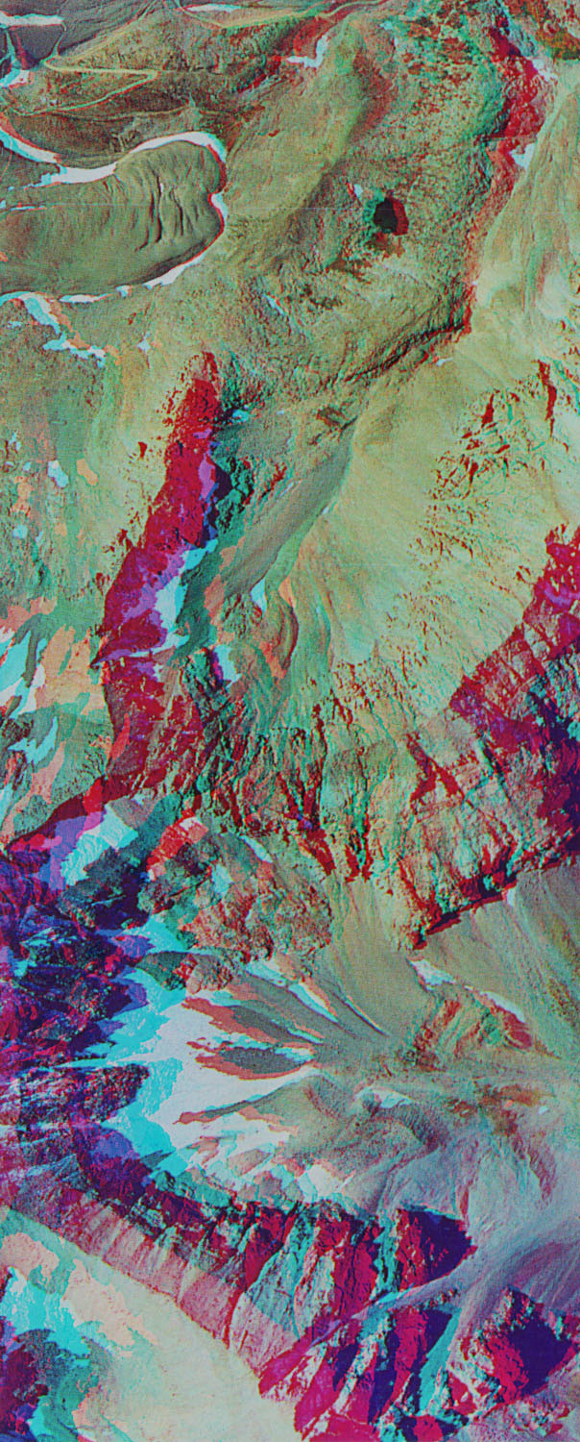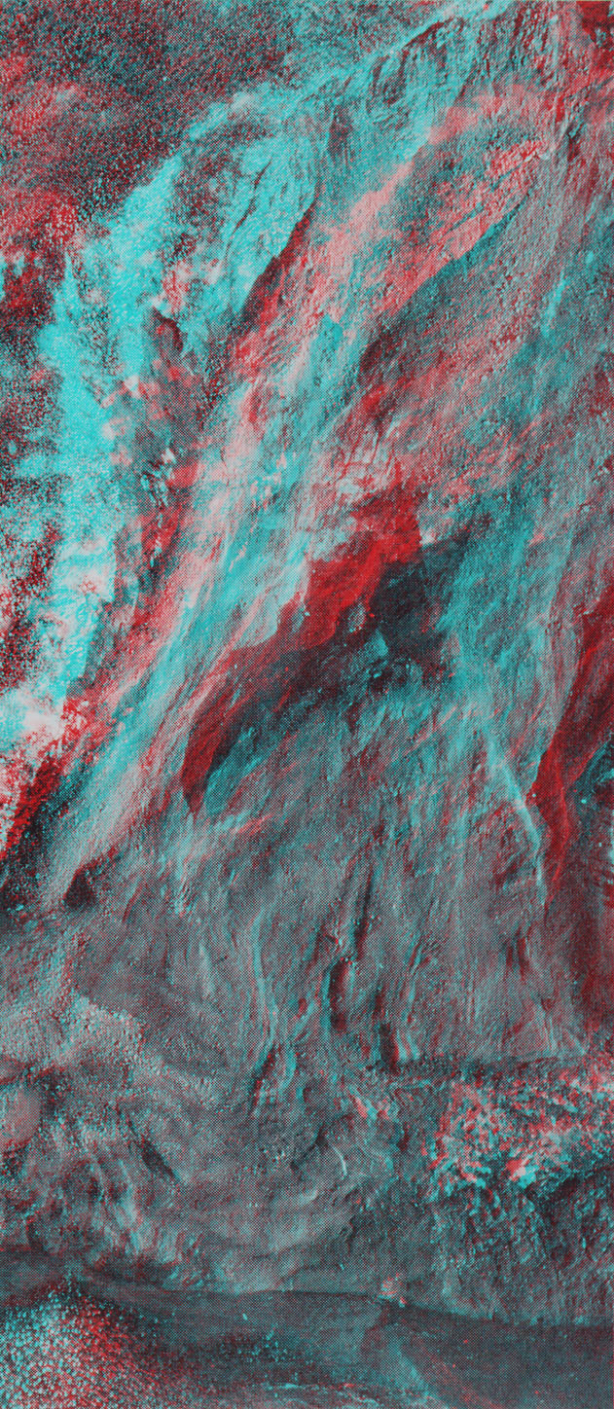

- Lake San Cristobal, Colorado (the topographic map)

This area is in the San Juan Mountains of Colorado. The rocks are mostly Tertiary volcanics, with andesites and pyroclastic rocks dominating.

3a. What is the origin of Lake San Cristobal? (list the sequence of events – hints are in the accompanying information

3b. What type of mass movement is the Slumgullion slide?

3c. What material most likely is involved in the Slumgullion slide?

3d. How thick is the slide debris near the shores of Lake San Cristobal (where Slumbullion Creek enters the lake)? – Hint, check the elevation of the shoreline and count the contours. Figure out the contour interval by counting the lines between the major index contours).

3e. What was the approximate depth of the lake when it was first formed (before it cut the outlet at Argenta Falls)?

3f. Trace the boundaries of the Slumgullion slide on the map, and draw an arrow pointing toward the source, or head, of the slide.

3g. What areas might be considered a high risk for future slides? Show these areas on the map with a red felt-tipped pen.



